**package** Thuresday;

**import** java.util.Scanner;

**public** **class** GFG

{

// Method to find the waiting time for all

// processes

**static** **void** findWaitingTime(**int** processes[], **int** n,

**int** bt[], **int** wt[], **int** quantum)

{

// Make a copy of burst times bt[] to store remaining

// burst times.

**int** rem_bt[] = **new** **int**[n];

**for** (**int** i = 0 ; i < n ; i++)

rem_bt[i] = bt[i];

**int** t = 0; // Current time

// Keep traversing processes in round robin manner

// until all of them are not done.

**while**(**true**)

{

**boolean** done = **true**;

// Traverse all processes one by one repeatedly

**for** (**int** i = 0 ; i < n; i++)

{

// If burst time of a process is greater than 0

// then only need to process further

**if** (rem_bt[i] > 0)

{

done = **false**; // There is a pending process

**if** (rem_bt[i] > quantum)

{

// Increase the value of t i.e. shows

// how much time a process has been processed

t += quantum;

// Decrease the burst_time of current process

// by quantum

rem_bt[i] -= quantum;

}

// If burst time is smaller than or equal to

// quantum. Last cycle for this process

**else**

{

// Increase the value of t i.e. shows

// how much time a process has been processed

t = t + rem_bt[i];

// Waiting time is current time minus time

// used by this process

wt[i] = t - bt[i];

// As the process gets fully executed

// make its remaining burst time = 0

rem_bt[i] = 0;

}

}

}

// If all processes are done

**if** (done == **true**)

**break**;

}

}

// Method to calculate turn around time

**static** **void** findTurnAroundTime(**int** processes[], **int** n,

**int** bt[], **int** wt[], **int** tat[])

{

// calculating turnaround time by adding

// bt[i] + wt[i]

**for** (**int** i = 0; i < n ; i++)

tat[i] = bt[i] + wt[i];}

// Method to calculate average time

**static** **void** findavgTime(**int** processes[], **int** n, **int** bt[],

**int** quantum)

{

**int** wt[] = **new** **int**[n], tat[] = **new** **int**[n];

**int** total_wt = 0, total_tat = 0;

// Function to find waiting time of all processes

*findWaitingTime*(processes, n, bt, wt, quantum);

// Function to find turn around time for all processes

*findTurnAroundTime*(processes, n, bt, wt, tat);

// Display processes along with all details

System.***out***.println("Processes " + " Burst time " +

" Waiting time " + " Turn around time");

// Calculate total waiting time and total turn

// around time

**for** (**int** i=0; i<n; i++)

{

total_wt = total_wt + wt[i];

total_tat = total_tat + tat[i];

System.***out***.println(" " + (i+1) + "\t\t" + bt[i] +"\t " +

wt[i] +"\t\t " + tat[i]);

}

System.***out***.println("Average waiting time = " +

(**float**)total_wt / (**float**)n);

System.***out***.println("Average turn around time = " +

(**float**)total_tat / (**float**)n);

}

// Driver Method

**public** **static** **void** main(String[] args)

{

// process id's

Scanner s = **new** Scanner(System.***in***);

System.***out***.print("Enter no. of processes:");

**int** n = s.nextInt();

**int** processes[] = **new** **int**[n];

**for**(**int** i = 0; i < n; i++)

{

processes[i] = i;

}

**int** burst_time[]= **new** **int**[n];

System.***out***.print("Enter burst time:");

**for**(**int** i = 0; i < n; i++)

{

burst_time[i] = s.nextInt();

}

// Time quantum

System.***out***.print("Enter time quantum:");

**int** quantum = s.nextInt();

*findavgTime*(processes, n, burst_time, quantum);

}

}

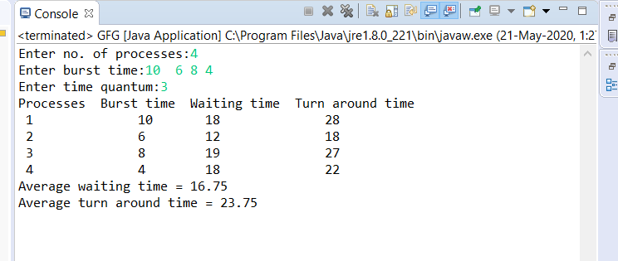 **OUTPUT**